Nexus Installation in Windows machine

Nexus repository

Before going to install nexus repository we have to set maven path and JDK path in environment variables as shown in the below pictures.

Go to system properties 🡪advanced system settings🡪environmental variables.

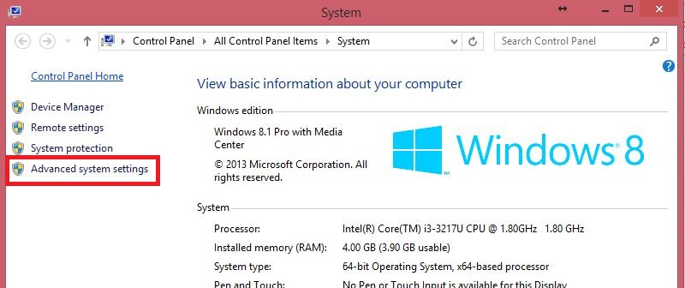

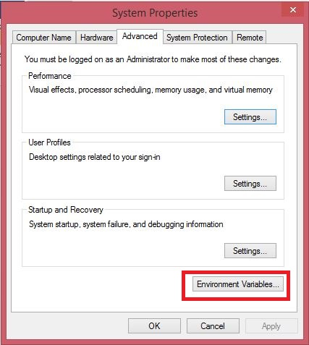

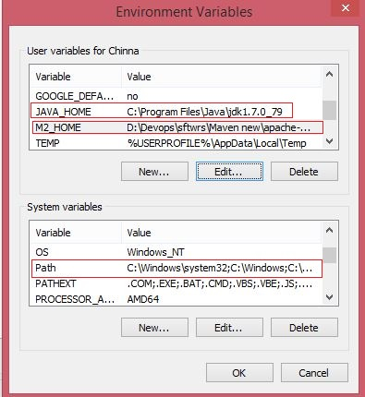

**Paths:**

**M2 path** : D:\Devops\sftwrs\Maven new\apache-maven-3.0.4-bin\apache-maven-3.0.4 (new Maven-3.0.4 path)

**JDK path** : C:\Program Files\Java\jdk1.7.0_79

Main Path : keep the coursor at the end to present path and then give ‘;’ then give latest maven path then save and exit.

Steps to install nexus repository:

Step1: Download Nexus from <https://www.sonatype.com/download-oss-sonatype>

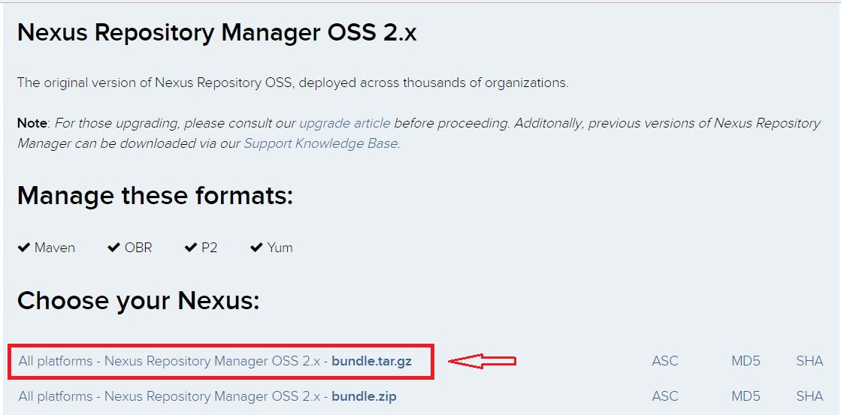

Click on the above marked bundle.tar.gz hyper link to download

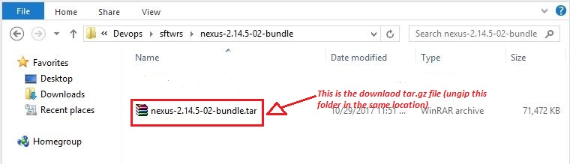

Step2: Unzip downloaded nexus folder in the same location then you will get **nexus-2.14.5-02** and **sonatype-work** as below.

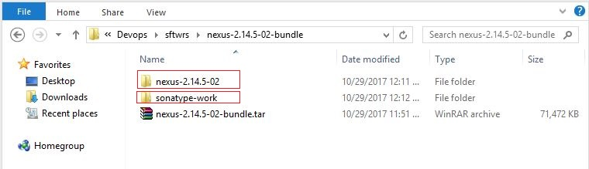

Step3: Copy both the marked folders to the location **C:\Program Files (x86)** in your local machine.

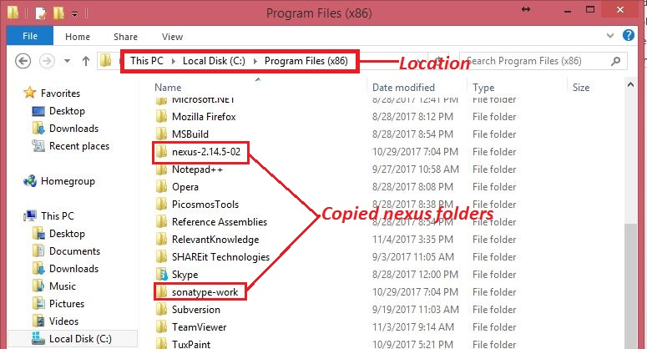

Step4: Click on start button in your windows machine and search for command prompt then open it as Administrator as shown below.

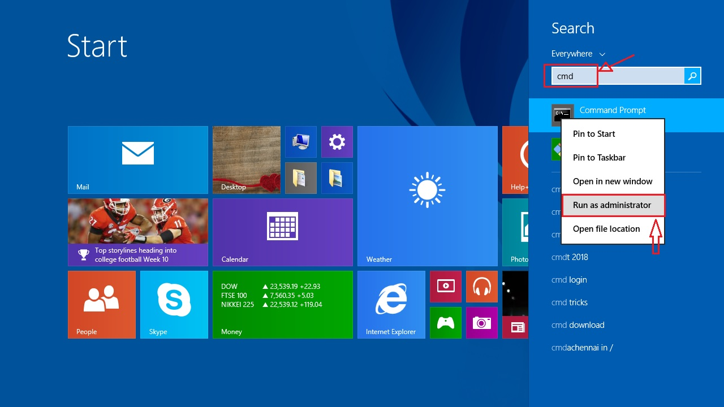

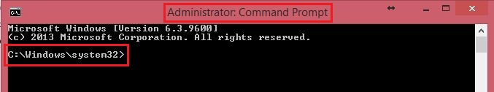

Step5: Go to the given path in your local machine **C:\Program Files (x86)\nexus-2.14.5-02\bin\jsw\windows-x86-64** and copy the path to command prompt using **cd** .

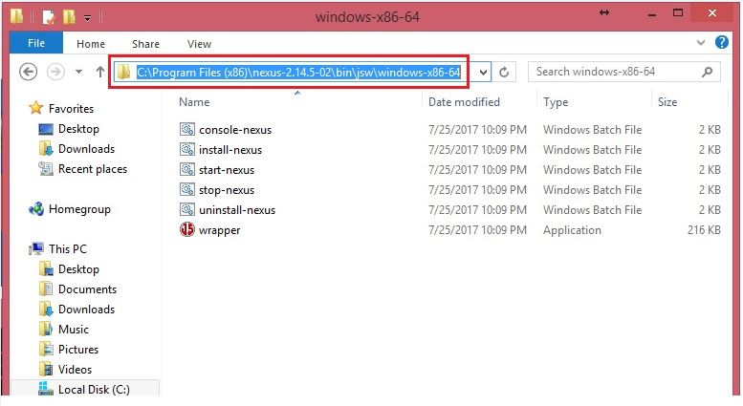

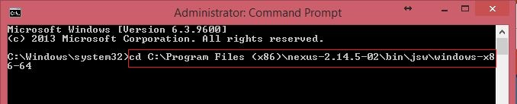

Step6: In that given path we have to run the command **# install-nexus.bat** in windows cmd prompt then nexus will automatically install in your local machine.

Step7: Open browser and enter the given link <http://localhost:8081/nexus> you will get error as below.

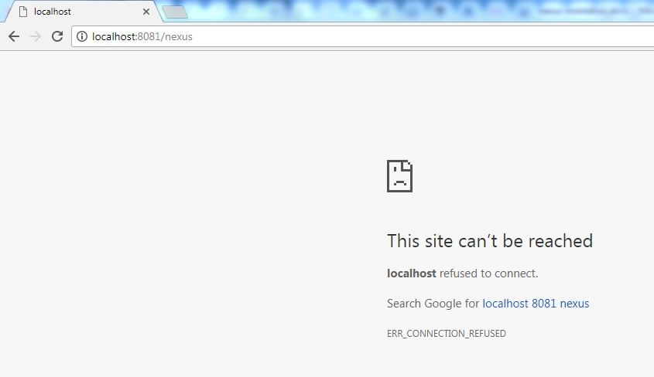

Step8: Here we have to start nexus service in your local machine in the following way.

Right click on Task bar and got **Task manager** you will get a new window, here you will find **services** tab click on that and search for nexus.

Right click on **nexus service** and click on **start** or **restart** option.

We have another option to get Task manager and services i.e, click on start button in local machine and search for **Task manager**.

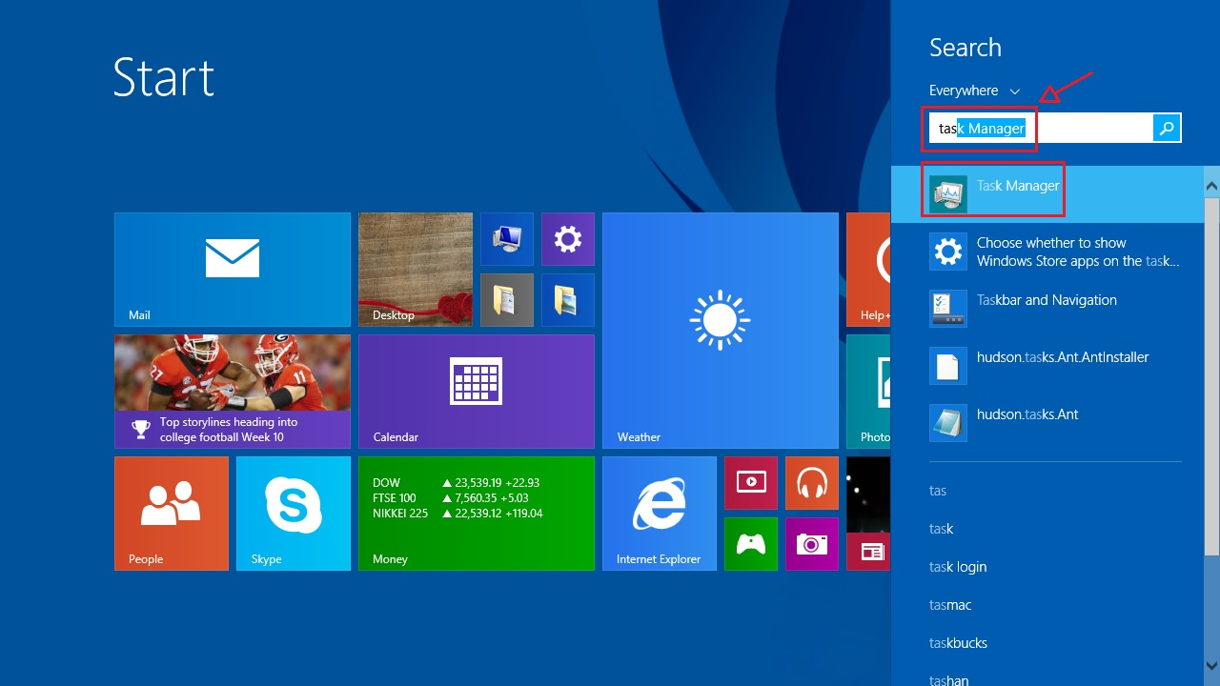

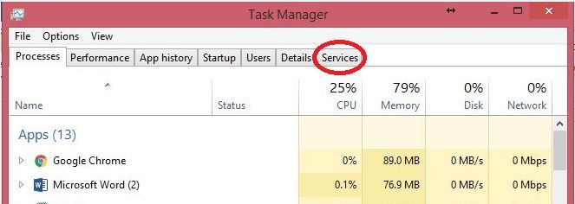

After clicking the services you will get list of services which are running in your local machine, then search for Nexus and start it as shown below for up and running.

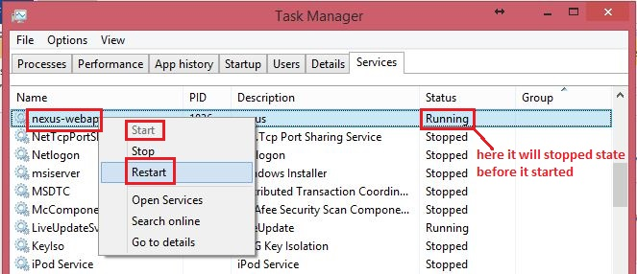

After that restart the browser then you will get the home page of nexus repository as given below.

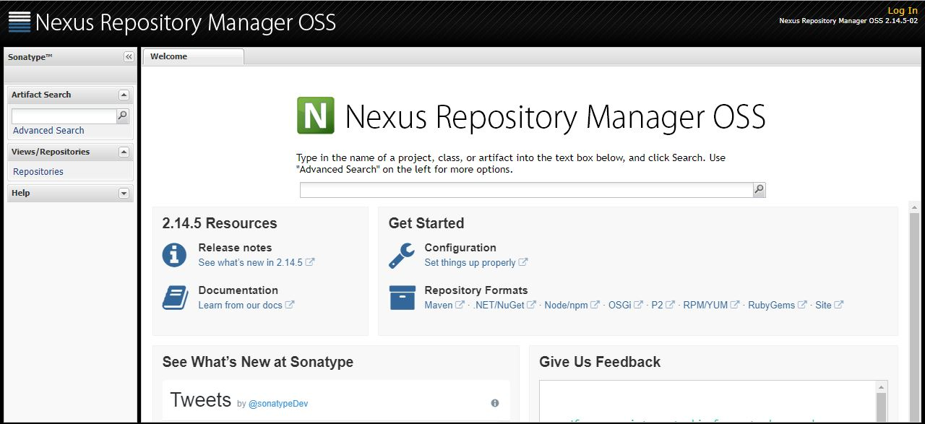

Click on Login option in the webpage and login to the nexus repository using below credentials.

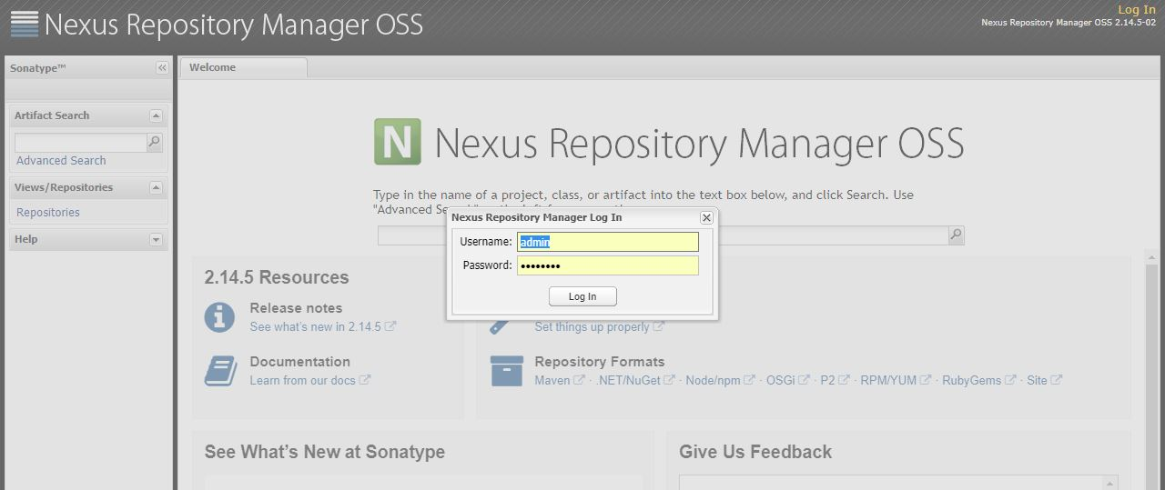

Username: admin

Password: admin123

Then you will login as admin into the nexus repository with various options as shown in the below picture.

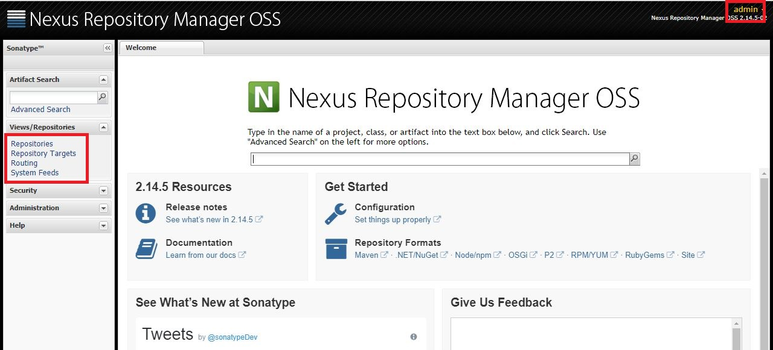

Step9: Here we have to create one repository with Id: **ARTECH**.

Click on the **Repositories** option in the nexus home page and then it will redirect to another page there you will find so many radio buttons and also list of in build repositories as below.

Click in **Add** radio button and select **Hosted Repository** to create a new repository.

In that we have given repo Id as **ARTECH** and repo name can be optional and then we have to select **Release** in **Repository Policy** and save it.

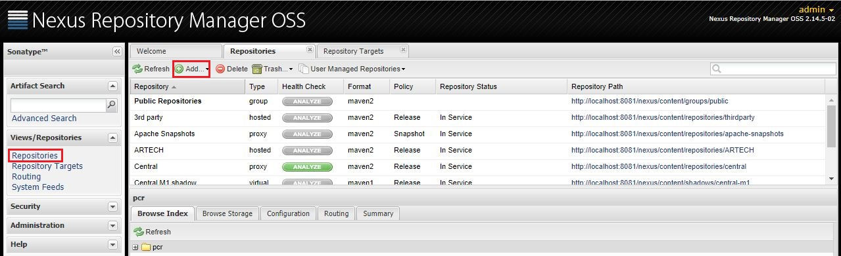

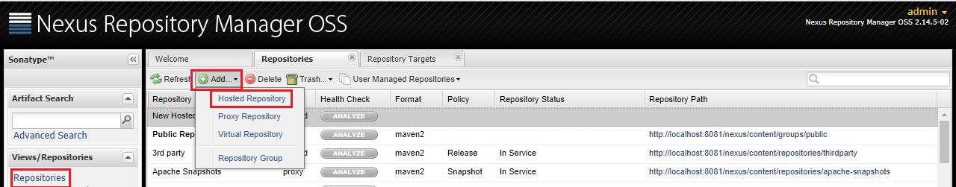

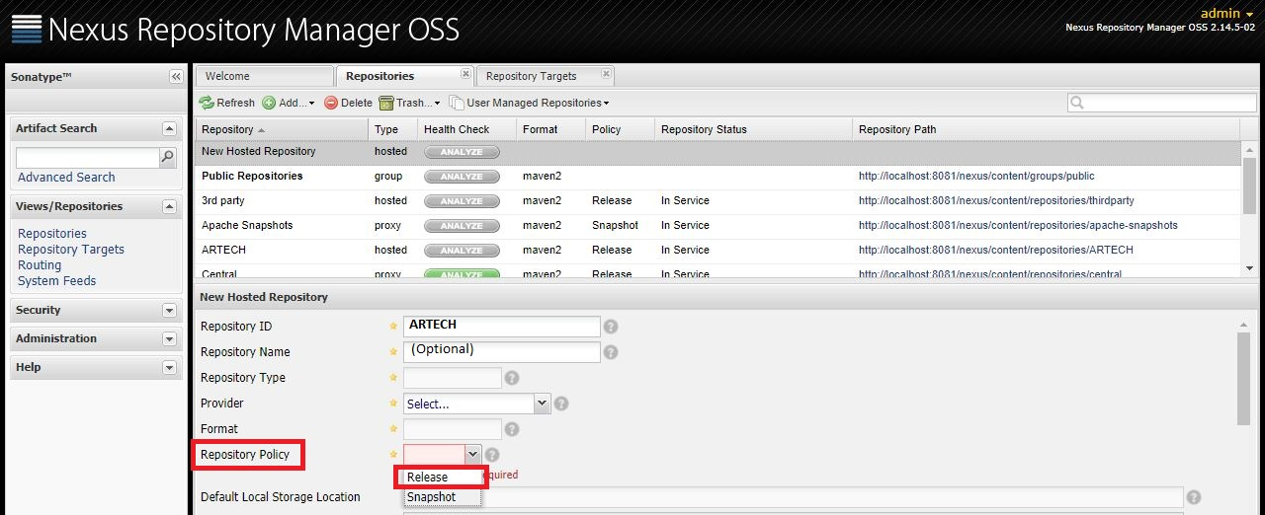

After creating the repository click on the created repo link the you will prompt to another page as below.

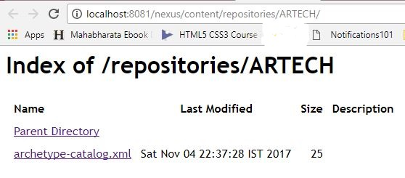

Step10: Create one more repository with any Id and any name and then select **Snapshot** in **Repository Policy.**

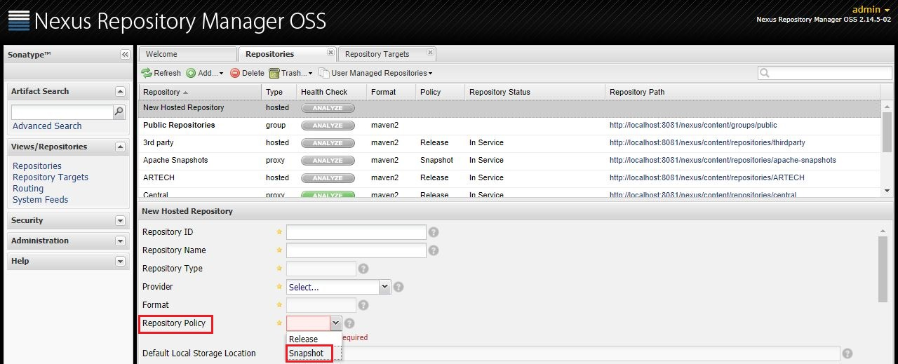

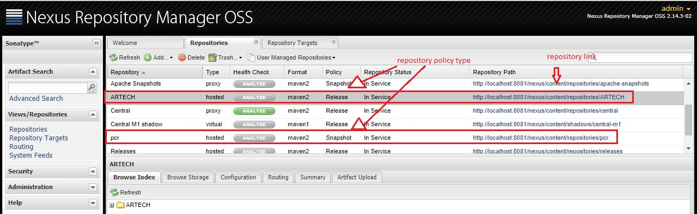

Step11: After that go to your local machine into .M2 folder and the create Settings.xml file and enter the below mentioned code.

This PC🡪C:/ drive🡪users🡪select local user🡪you will get .M2 folder and then get into the folder then create **Settings.xml** .

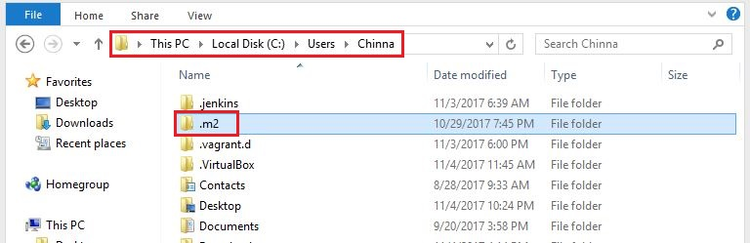

**Code for Settings.xml:**

<?xml version="1.0" encoding="UTF-8"?>

<settings xmlns="http://maven.apache.org/SETTINGS/1.0.0"

xmlns:xsi="http://www.w3.org/2001/XMLSchema-instance"

xsi:schemaLocation="http://maven.apache.org/SETTINGS/1.0.0 http://maven.apache.org/xsd/settings-1.0.0.xsd">

<activeProfiles>

<!--make the profile active all the time -->

<activeProfile>insecurecentral</activeProfile>

</activeProfiles>

<pluginGroups>

<pluginGroup>org.sonarqubesource.scanner.maven</pluginGroup>

</pluginGroups>

<profiles>

<profile>

<id>insecurecentral</id>

<!--Override the repository (and pluginRepository) "central" from the Maven Super POM -->

<repositories>

<repository>

<id>central</id>

<url>http://repo.maven.apache.org/maven2</url>

<releases>

<enabled>true</enabled>

</releases>

</repository>

</repositories>

<pluginRepositories>

<pluginRepository>

<id>central</id>

<url>http://repo.maven.apache.org/maven2</url>

<releases>

<enabled>true</enabled>

</releases>

</pluginRepository>

</pluginRepositories>

</profile>

<profile>

<id>sonar</id>

<activation>

<activeByDefault>true</activeByDefault>

</activation>

<properties>

<!-- Optional URL to server. Default value is http://localhost:9000 -->

<sonar.host.url>

http://localhost:9000

</sonar.host.url>

</properties>

</profile>

</profiles>

<servers>

<server>

<id>MAVEN-RELEASE</id>

<username>admin</username>

<password>admin123</password>

</server>

<server>

<id>MAVEN-SNAPSHOT</id>

<username>admin</username>

<password>admin123</password>

</server>

</servers>

</settings>

After creating the settings.xml go to pom.xml file and add repositories URL and ID in the **distribution management**.

Copy Release repository and Snapshot repository url’s along with their Id’s from the nexus and paste them in pom.xml as below.

**Pom.xml code:**

**<project xmlns="http://maven.apache.org/POM/4.0.0" xmlns:xsi="http://www.w3.org/2001/XMLSchema-instance"**

**xsi:schemaLocation="http://maven.apache.org/POM/4.0.0 http://maven.apache.org/maven-v4_0_0.xsd">**

**<modelVersion>4.0.0</modelVersion>**

**<groupId>com.maaven.practice</groupId>**

**<artifactId>myapp</artifactId>**

**<packaging>jar</packaging>**

**<version>1.0-SNAPSHOT</version>**

**<dependencies>**

**<dependency>**

**<groupId>junit</groupId>**

**<artifactId>junit</artifactId>**

**<version>3.8.1</version>**

**<scope>test</scope>**

**</dependency>**

**</dependencies>**

**<distributionManagement>**

**<repository>**

**<id>MAVEN-RELEASE</id>**

**<url>http://localhost:8081/nexus/content/repositories/MAVEN-RELEASE/</url>**

**</repository>**

**<snapshotRepository>**

**<id>MAVEN-SNAPSHOT</id>**

**<url>http://localhost:8081/nexus/content/repositories/MAVEN-SNAPSHOT/</url>**

**</snapshotRepository>**

**</distributionManagement>**

**</project>**

Step12: After that create a job in Jenkins using CI as in the following way.

Open Jenkins 🡪 Mange Jenkins 🡪 configure system here we have to give invoke maven as below and then save and exit.

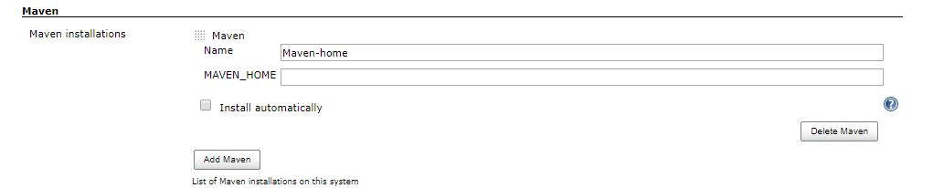

Go to Node or slave open it’s configure here we have to set maven path and also all the paths as shown below then save and exit.

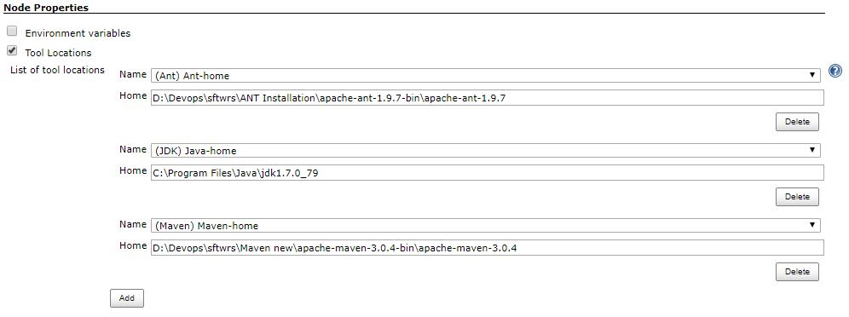

After that create a new job with name CI_Maven_Nexus by selecting it as maven project as shown below and then click on **ok** .

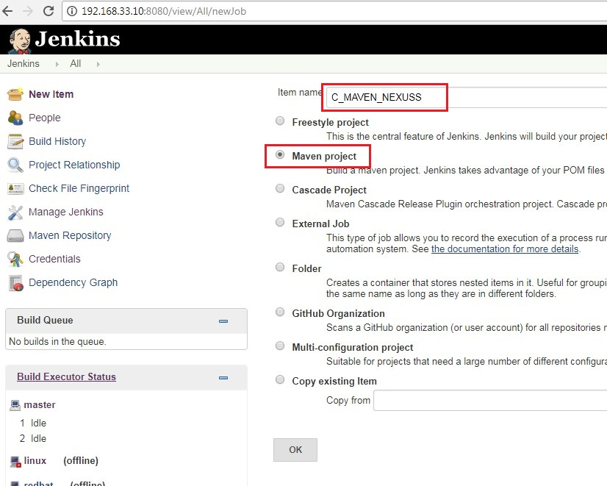

Inside project we have to give the below details.

1. We have to select **Restrict where this project can be run** and there we have to enter **Node** or **Slave** name.



1. Select **Subversion** in **Source code management** and then give check-in repository URL.

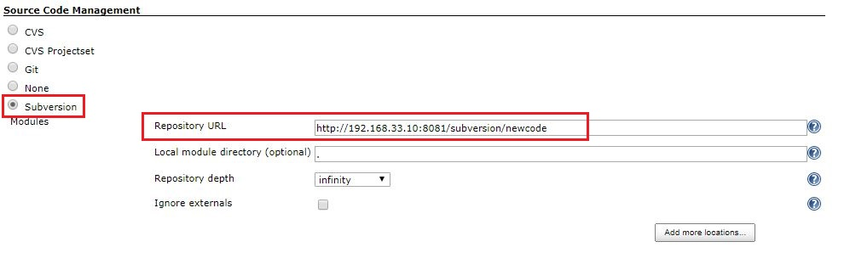

1. Go to **Post Steps** and then select **Invoke top-level maven targets** and give details as below.

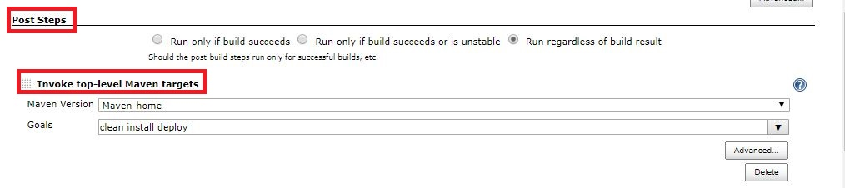

1. Go to **Post-Build Actions** and select **Archive the artifacts** then give the details as below and then save the job.

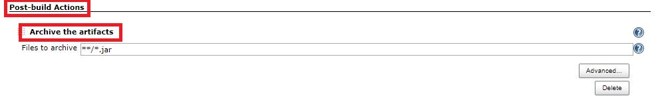

Now click on the **Build-now** option to build the job then you will get the output as following in the Jenkins.

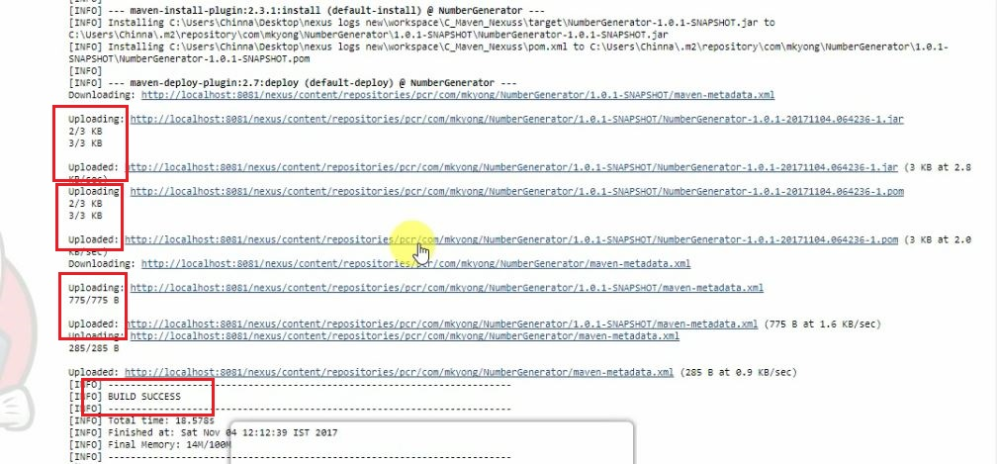

Then go to nexus and refresh the page then you will get the Snapshot output as in the following way.

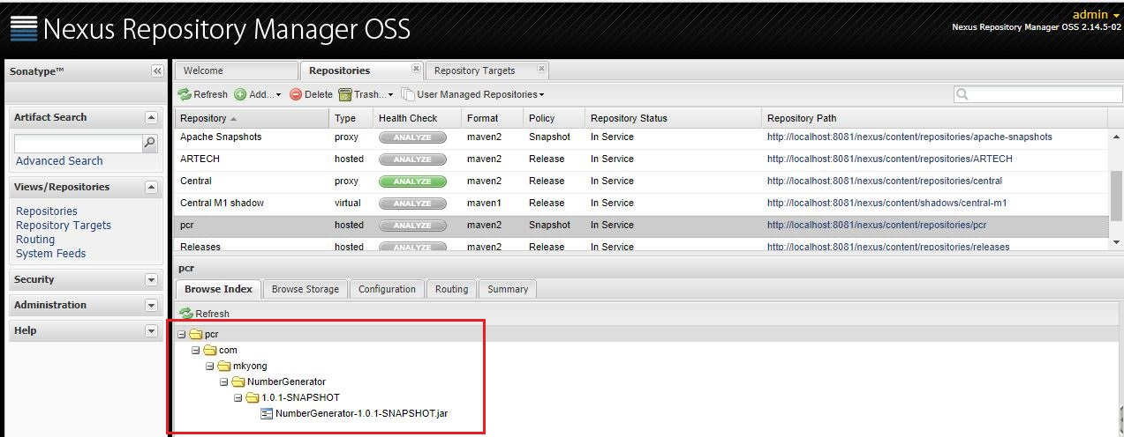

If you open the repository url in separate tabs you will get nexus page as follows.

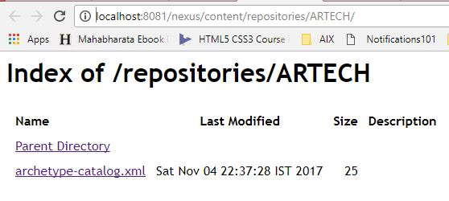

If you open Snapshot url you will get in the following way.

